SQT UNIT 2
1) Explain the Test Plan Format with its components?
ANS)
A Test Plan is a descriptive document that describes the test approach, purpose, plan, estimation, results, and resources required for testing. It assists us in regulating the effort required to verify the quality of the application under test.
The Test Plan acts as a layout to implement Software Testing activities as a defined process that is closely observed and supervised by the Test Manager.
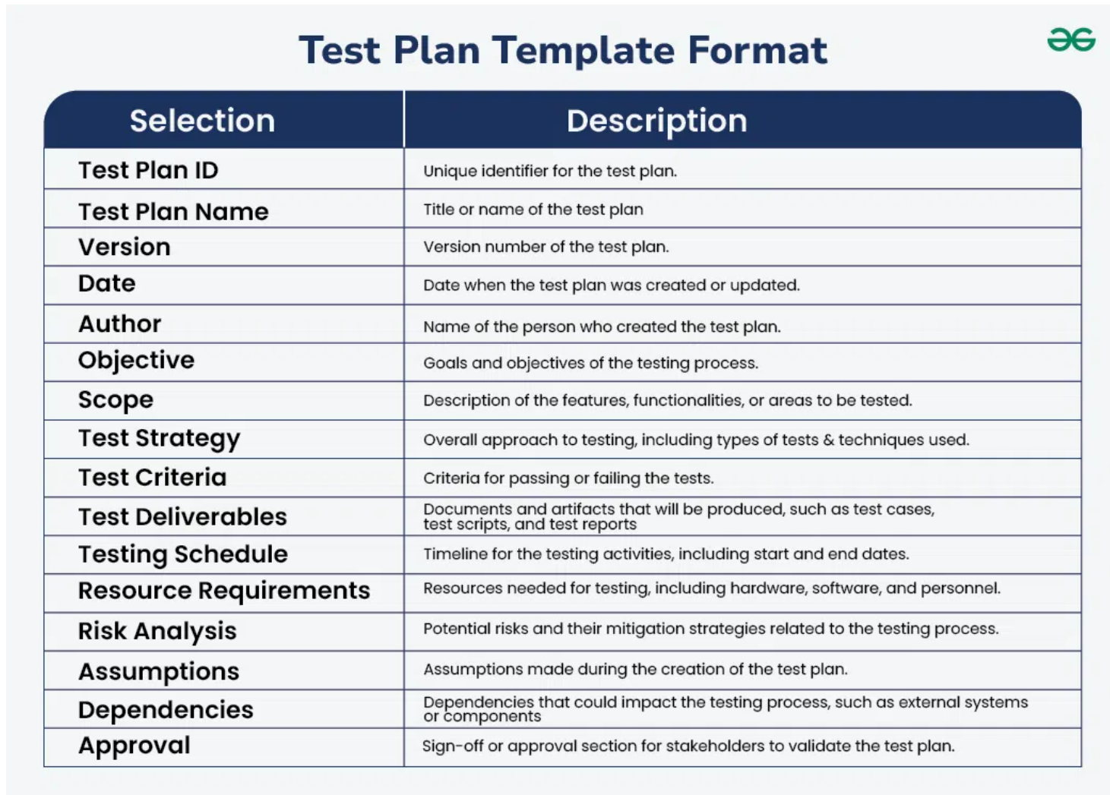
Steps to Create an Efficient Test Plan
Step 1: Define the Release Scope
- Clearly outline the features, functionalities, and components that need to be tested in this release.
- Identify any features that are out of scope to avoid unnecessary testing.
Step 2: Schedule Timelines
- Set realistic deadlines for each phase of the testing process.
- Include buffer time for unexpected delays or issues.
Step 3: Define Test Objectives
- Specify the goals of the testing process, such as verifying functionality, performance, and security.
- Align these objectives with the overall project requirements.
Step 4: Determine Test Deliverables
- Before Testing: Create and review the test plan, test cases, and test environment setup.
- During Testing: Execute test cases, log defects, and monitor progress.
- After Testing: Provide test reports, defect logs, and sign-off documents.
Step 5: Design the Test Strategy
- Choose the appropriate testing methodologies, such as manual testing, automation, or performance testing.
- Outline the tools and techniques to be used for each type of testing.
Step 6: Plan the Test Environment and Test Data
- Define the hardware, software, and network requirements for the test environment.
- Prepare the necessary test data, including both valid and invalid data sets, to ensure comprehensive testing.

2) Define a Test Scenario and provide an example?
ANS)
Definition of Test Scenario:
A Test Scenario is a high-level description of what functionality needs to be tested in an application. It is derived from business requirements and user stories. Test scenarios focus on real-world user flows rather than individual inputs or outputs.
- A test scenario is a collective set of test cases that helps the testing team determine the positive and negative features of the project.
- It provides a high-level description of what has to be tested.
- It is defined as a linear statement.
- It is a detailed document that covers end to end functionality of a software application.
- It is a useful exercise for saving time.
- It is simple to maintain as adding and modifying test cases is simple.

Importance of Test Scenarios:
- Ensures Requirement Coverage – Every requirement is converted into at least one scenario, so nothing is missed.
- Saves Time – Provides a quick way to identify test areas before writing detailed test cases.
- Improves Communication – Written in simple language, so business analysts, developers, and testers can understand.
- Helps Prioritization – Test scenarios help in deciding which features are critical to test first.
- Acts as Basis for Test Cases – Test cases are created from scenarios for detailed step-by-step execution.
Example – ATM Cash Withdrawal (Banking Application):
- Test Scenario: Verify ATM cash withdrawal process.
Derived Test Cases:
- Insert valid card, enter correct PIN, and withdraw cash within available balance → Cash should be dispensed.
- Insert valid card, enter incorrect PIN three times → Card should be blocked.
- Insert valid card, enter correct PIN, but request amount greater than balance → Transaction should be declined.
- Attempt withdrawal from a non-operational ATM → Appropriate error message should be displayed.
- Withdraw amount exceeding daily transaction limit → Transaction should be rejected.
3) What is a Test Case? Write an example for ATM withdrawal?
ANS)
Test cases are sets of actions that are executed to verify particular features or functionality of software applications. It consists of test data, test steps, preconditions, and post conditions that are developed for specific test scenarios to verify any requirement.
- Test cases are mostly derived from test scenarios.
- It helps in the exhaustive testing of software.
- Test cases include test steps, data, and expected outcomes for testing.
- These are low-level actions and require more time and resources for execution.
Key Elements of a Test Case:
- Test Case ID – A unique identifier given to each test case, like TC01 or TC02, so it can be easily tracked and referred to.
- Preconditions – The conditions that must be fulfilled before the test can be executed, for example, the user should have a valid ATM card and sufficient balance.
- Test Steps – The detailed actions the tester needs to follow to perform the test, such as inserting the card, entering the PIN, and selecting withdrawal.
- Test Data – The specific input values used in the test, such as entering a withdrawal amount of ₹500.
- Expected Result – The correct outcome predicted before running the test, like cash of ₹500 should be dispensed and the balance reduced.
- Actual Result – The real outcome observed after performing the test. It may match the expected result or show an error if there’s a defect.
Example – ATM Cash Withdrawal
- Test Case ID: TC01
- Title: ATM Cash Withdrawal – Valid Transaction
- Preconditions: Account has sufficient balance, and the ATM card is active.
Steps with Explanation:
- Insert ATM card – The user places their debit/ATM card into the machine to start the transaction.
- Enter valid PIN – The user types their Personal Identification Number to verify their identity.
- Select Cash Withdrawal – From the ATM menu, the user chooses the option to withdraw cash.
- Enter amount (e.g., ₹2000) – The user specifies how much money they want to withdraw.
- Confirm transaction – The user confirms the entered details so the ATM can process the request.
Expected Result:
- The ATM should dispense the requested cash.
- The account balance should be reduced by ₹2000.
- A transaction receipt should be generated.

4) Differentiate between Positive and Negative Test Cases?
ANS)
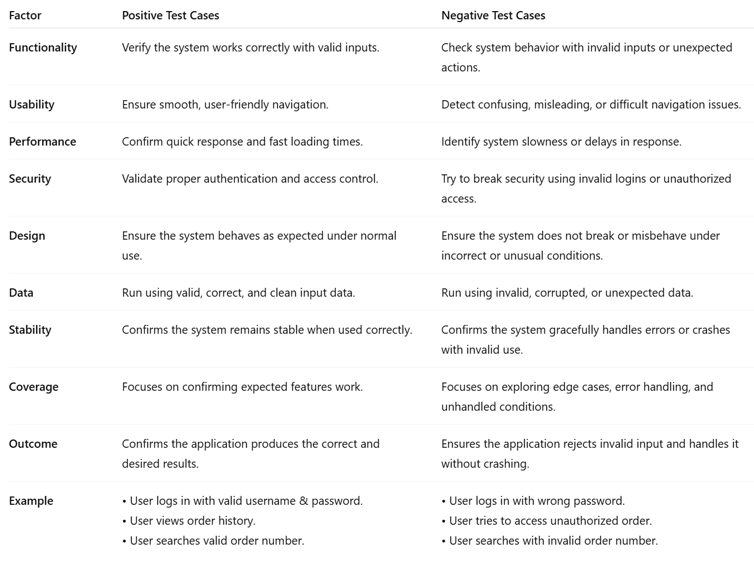
5) Write 3 positive and 3 negative test cases for user registration?
ANS)
Positive Test Cases
Test Case 1: Successful Registration with Valid Data
- Test Case ID: TC_REG_01
- Preconditions: User is on the registration page.
- Steps:
  - Enter valid username (e.g., John123).
  - Enter valid email (e.g., john@example.com).
  - Enter strong password (e.g., John@1234).
  - Re-enter the same password in Confirm Password.
  - Click on "Register".
- Test Data: Username = John123, Email = john@example.com, Password = John@1234
- Expected Result: Registration is successful, and the user is redirected to the login page or dashboard.
- Actual Result: To be filled after execution.
Test Case 2: Registration with All Mandatory Fields Filled
- Test Case ID: TC_REG_02
- Preconditions: User is on the registration page.
- Steps:
  - Enter valid username.
  - Enter valid email.
  - Enter password and confirm password.
  - Leave optional fields (like phone number, address) empty.
  - Click "Register".
- Test Data: Username = Alex007, Email = alex@test.com, Password = Alex@5678
- Expected Result: Registration should be successful, as optional fields are not required.
- Actual Result: To be filled after execution.
Test Case 3: Password Meets Security Rules
- Test Case ID: TC_REG_03
- Preconditions: User is on the registration page.
- Steps:
  - Enter valid username.
  - Enter valid email.
  - Enter a password with at least 8 characters, including letters, numbers, and special characters.
  - Confirm the password.
  - Click "Register".
- Test Data: Username = Sara89, Email = sara@mail.com, Password = Sara@2025
- Expected Result: Registration should be successful since the password meets security requirements.
- Actual Result: To be filled after execution.
Negative Test Cases
Test Case 4: Registration with Invalid Email Format
- Test Case ID: TC_REG_04
- Preconditions: User is on the registration page.
- Steps:
  - Enter valid username.
  - Enter invalid email (e.g., user@.com).
  - Enter valid password and confirm password.
  - Click "Register".
- Test Data: Username = Rahul01, Email = user@.com, Password = Rahul@123
- Expected Result: System should display an error message like “Invalid email format” and not register the user.
- Actual Result: To be filled after execution.
Test Case 5: Password and Confirm Password Mismatch
- Test Case ID: TC_REG_05
- Preconditions: User is on the registration page.
- Steps:
  - Enter valid username and email.
  - Enter password (e.g., Pass@123).
  - Enter different confirm password (e.g., Pass@321).
  - Click "Register".
- Test Data: Username = Meera88, Email = meera@domain.com, Password = Pass@123, Confirm Password = Pass@321
- Expected Result: System should show an error message like “Passwords do not match” and not allow registration.
- Actual Result: To be filled after execution.
Test Case 6: Mandatory Fields Left Blank
- Test Case ID: TC_REG_06
- Preconditions: User is on the registration page.
- Steps:
  - Leave username blank.
  - Leave password blank.
  - Enter only email.
  - Click "Register".
- Test Data: Username = (blank), Email = raj@domain.com, Password = (blank)
- Expected Result: System should display validation messages like “Username is required” and “Password is required”.
- Actual Result: To be filled after execution.

6) List and explain 5 key points to be considered while creating a test plan?
ANS)
Key Points to Consider While Creating a Test Plan
1. Scope of Testing
- Description: Clearly define what will be tested and what will not be tested.
- Purpose: Ensures the team focuses only on relevant features, modules, or functionalities and avoids wasted effort.
- Example:
  - In-Scope: User registration, login, product search, shopping cart, and payment gateway of an E-commerce website.
  - Out-of-Scope: Third-party vendor systems or mobile app features if the current release is web-based only.
2. Testing Objectives
- Description: State the purpose of testing, such as finding defects, ensuring reliability, and validating requirements.
- Purpose: Helps align the team and stakeholders on the expected outcomes of the testing effort.
- Example Objectives:
  - Validate that all functional requirements are met.
  - Detect defects before the product reaches customers.
  - Ensure the software works on multiple devices and browsers.
  - Confirm that the system can handle up to 10,000 users simultaneously.
3. Resources and Responsibilities
- Description: Identify the team members, tools, hardware, and software required.
- Purpose: Assign clear roles and responsibilities to avoid duplication of work and ensure accountability.
- Example Allocation:
  - Test Manager: Prepare test plan, monitor progress.
  - Test Engineers: Execute test cases, log defects.
  - Automation Engineer: Develop and run automated scripts.
  - Tools Used: JIRA (defect tracking), Selenium (automation), Postman (API testing).
4. Test Environment Setup
- Description: Describe the hardware, software, network, and test data required to execute tests.
- Purpose: Ensures consistency and avoids issues caused by environment differences.
- Example Setup:
  - Hardware: 8 GB RAM, Intel i5 processor.
  - Software: Windows 11, Chrome v120, MySQL database.
  - Network: Internet bandwidth of at least 50 Mbps.
  - Test Data: Sample user accounts with valid/invalid credentials, fake credit card numbers for payment gateway testing.
5. Entry and Exit Criteria
- Description: Define the conditions that determine when to start and when to stop testing.
- Purpose: Prevents testing from starting prematurely and ensures clear conditions for completion.
- Example:
  - Entry Criteria:
    - All functional requirements are documented.
    - Code is unit-tested and stable.
    - Test environment is ready.
  - Exit Criteria:
    - 95% of test cases executed successfully.
    - No critical or high-priority defects remain unresolved.
    - Test summary report prepared and signed off.

7) What is the importance of Suspension and Resumption Criteria in testing?
ANS)
Software testing is one of the most critical phases in the software development lifecycle (SDLC). It ensures that the product being delivered to the end user is reliable, stable, and functions as expected. However, testing is not always straightforward. There are times when it cannot continue due to various reasons, such as critical defects in the application, environment instability, or missing resources. To handle such situations effectively, the test plan defines two essential elements: suspension criteria and resumption criteria. These criteria play a vital role in ensuring that testing is performed efficiently, effectively, and under valid conditions.

Suspension Criteria:
- Suspension criteria refer to the specific conditions under which testing activities should be temporarily stopped. They act as a safeguard to prevent testers from continuing their work when the application under test (AUT) is not in a suitable state for meaningful testing. Common suspension conditions include:
- Frequent crashes or instability in the software build.
- Unavailability of the required test environment or test data.
- Failure of essential system components that are prerequisites for further testing.
Importance

Prevents Waste of Resources
Continuing to test an unstable or non-functional build is a waste of time, effort, and money. Testers may spend hours executing test cases that inevitably fail due to the same underlying defect.
Ensures Accuracy of Test Results
If testers continue working on an unstable build, the test results may not accurately reflect the true quality of the product. Many test cases may fail not because the functionality is incorrect, but because the system itself is not stable enough.

Protects Tester Morale
Constantly encountering failures due to system crashes or environment issues can frustrate and demotivate testers.
Improves Risk Management
Software testing inherently involves risks, including delays, cost overruns, and overlooked defects. Suspension criteria act as a risk control measure by ensuring that testing does not proceed under unsuitable conditions
Resumption Criteria
Resumption criteria define the conditions under which suspended testing can safely resume. These criteria ensure that testing is restarted only after the issues that caused the suspension are resolved. Common resumption conditions include:
- Fixing and retesting of all critical or blocking defects.
- Availability of a stable and functional build.
- Restoration of the test environment, infrastructure, or test data.
- Confirmation from developers or stakeholders that the application is in a testable state.
Importance
Clarity on When to Restart
Without clear resumption criteria, there may be confusion about when testing should continue. Some testers may try to restart too early, while others may wait unnecessarily. Resumption criteria provide clarity, ensuring everyone is aligned on the conditions required to resume.

Ensures Stability Before Retesting
Testing should not resume until the system is stable. Resumption criteria guarantee that critical defects are fixed and the build is reliable enough for continued testing. This ensures that time is spent productively.

Maintains Continuity of the Testing Process
By setting specific resumption conditions, teams can transition smoothly from suspension back to execution. This continuity ensures that testing progress is not permanently derailed by temporary issues.
Reduces Risk of Rework
If testing resumes before critical issues are fixed, many test cases may fail again, requiring re-execution later. Resumption criteria minimize this risk by ensuring that testers resume only after stability is restored.

By using Suspension and Resumption Criteria in testing
Improved Efficiency
Resources are not wasted on testing unstable software, and testing resumes promptly once conditions are right. This optimizes the use of time, effort, and cost.
Higher Quality Test Results
By ensuring testing is performed only under stable conditions, the results obtained are more reliable, accurate, and reflective of the product’s true quality.
Stronger Risk Management
These criteria minimize risks such as project delays, cost overruns, and inaccurate quality assessments by ensuring testing occurs only in valid conditions.

Suspension and resumption criteria are critical components of any well-prepared test plan. Suspension criteria protect the efficiency, reliability, and morale of the testing process by halting activities when the system is unstable or unsuitable for testing. Resumption criteria, in turn, ensure that testing resumes only when stability is restored and conditions are favourable. Together, they save resources, maintain the accuracy of test results, reduce risks, and improve communication across teams.

8) Explain how Test Deliverables are documented in a test plan. Give examples?
ANS)
In software testing, a test plan is the guiding document that defines the objectives, scope, approach, resources, and schedule for testing activities. One of the most critical components of a test plan is the section on test deliverables. Test deliverables are the artifacts produced during and after the testing process, which provide evidence of testing activities, results, and overall product quality. They act as tangible outputs that can be shared with stakeholders such as project managers, clients, or auditors.

Test deliverables are defined as any documents, reports, tools, or other outputs created during the testing process. They can be divided into three broad categories:

- Before Testing (Planning Phase) – Documents prepared before actual execution begins, such as the test plan or test design documents.
- During Testing (Execution Phase) – Documents created while tests are executed, such as test cases, test scripts, and defect reports.
- After Testing (Closure Phase) – Documents delivered after testing is complete, such as test summary reports, release notes, and lessons learned.

By including these in the test plan, teams establish a contract of sorts with stakeholders, ensuring that everyone knows what documentation and artifacts will be produced.

Importance of Documenting Test Deliverables in a Test Plan:
- Clarity and Transparency
- Standardization
- Accountability
- Progress Tracking
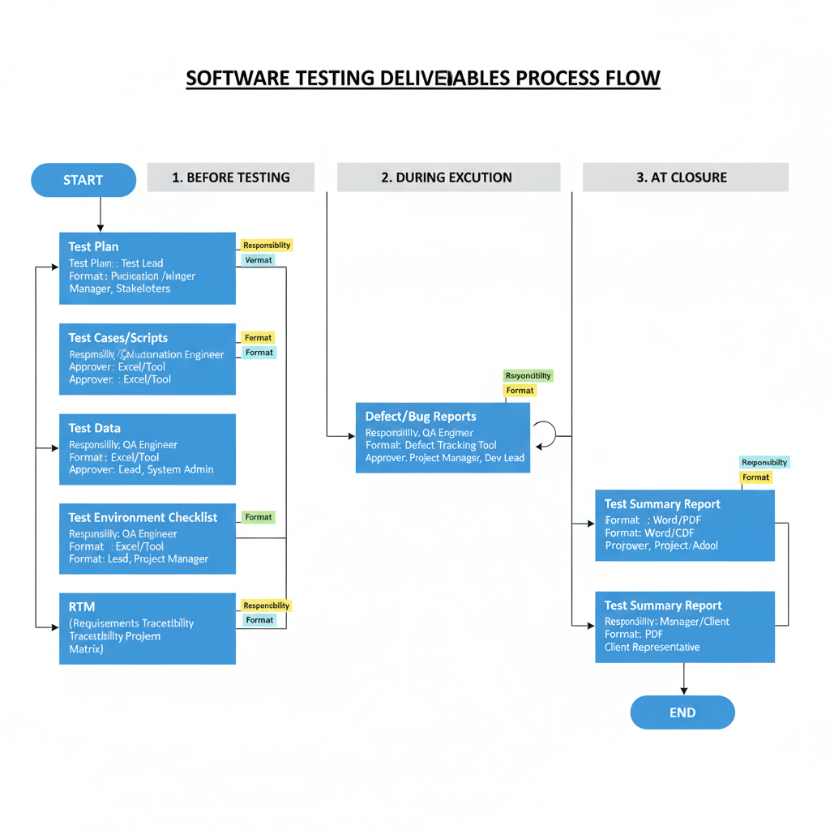
- Evidence for Quality Assurance and Compliance

In a test plan test deliverables are usually documented in a dedicated section called “Test Deliverables”. They are:
List of Deliverables
A clear enumeration of all deliverables expected across the testing phases.
Description of Each Deliverable
Explanation of the purpose, scope, and intended audience of each document or artifact.
Format and Standards
Indicating whether the deliverable will be in Word, Excel, PDF, or tool-generated reports. Also mention templates, naming conventions, or standards to be followed.
Responsibility and Ownership
Identify the person or role (e.g., Test Lead, QA Engineer, Automation Engineer) responsible for preparing and maintaining the deliverable.
Schedule of Delivery
Define when each deliverable will be produced (e.g., before testing starts, during execution, at closure).
Approval Process
State who will review and approve the deliverable (e.g., QA Manager, Project Manager, Client Representative).
To understand this better, let’s go through examples across different phases of testing:
- Before Testing (Planning Phase):
  - Test Plan Document:
    - Defines scope, objectives, resources, schedule, and risks of testing.
  - Test Design Specifications
    - Details the design of test cases, inputs, outputs, and environmental needs.
  - Test Environment Setup Document
    - Specifies hardware, software, network, and configuration required for testing.
- During Testing (Execution Phase)
  - Test Cases and Test Scripts
    - Step-by-step instructions to validate specific requirements. Test scripts can be manual or automated.
  - Test Data
    - Input values required to execute tests, such as user credentials, sample transaction data, or files.
  - Defect Reports / Bug Logs
    - Records details of defects found during execution, including severity, priority, and steps to reproduce.
  - Execution Logs and Screenshots
    - Logs or visual proof of test execution, especially in automated testing.
    - It provides evidence of test behavior and helps debugging.
- After Testing (Closure Phase)
  - Test Summary Report (TSR)
    - Summarizes overall testing activities, including number of test cases executed, passed, failed, and blocked. Also covers defect density, open issues, and quality assessment.
  - Release Notes / Readiness Report
    - Provides information on the tested build, major fixes, known issues, and deployment instructions.
  - Metrics and Dashboards
    - Charts, graphs, or KPIs generated to analyze testing effectiveness. Examples include defect rejection rate, requirement coverage, and automation percentage.
  - Lessons Learned Document
    - Captures insights and recommendations for future projects. Helps in process improvement.
  - Final Test Deliverables Handover
    - Organized package of all testing artifacts, archived for future reference or audits.
Test deliverables are the backbone of the testing process. By documenting them in the test plan, teams set clear expectations about what will be produced, when it will be delivered, and who will be responsible. Deliverables provide evidence of testing, support decision-making, and improve transparency and accountability.

9) Explain the significance of the "Features Not to be Tested" section in a Test Plan?
ANS)
In software testing, a test plan acts as the master document that guides the entire testing process. It defines the scope, objectives, approach, resources, deliverables, and schedule for testing activities. One of the most crucial aspects of a test plan is the definition of scope—what will be tested and, equally importantly, what will not be tested.

Features Not to be Tested refers to the list of application components, functionalities, or quality attributes that will not be covered during the testing cycle. These exclusions are made intentionally, usually due to constraints such as time, cost, resource availability, technical feasibility, or project priorities.
For example:
- If an e-commerce website is being tested, the admin dashboard might not be tested in a particular release if the scope focuses only on the customer-facing application.
- A mobile app project might exclude support for older operating systems if they are no longer officially supported.

Significance of Features Not to be Tested

1. Defining Clear Scope Boundaries
One of the biggest risks in testing is scope creep—where additional unplanned tasks gradually expand the workload. By explicitly stating what is out of scope, the test plan protects the team from being asked later why certain areas were not tested. It acts as a boundary line, showing what is intentionally excluded.
2. Avoids Misunderstandings Among Stakeholders
Different stakeholders—clients, developers, testers, and managers—often have different expectations. A client might assume that the testing team will validate every single feature, while the testing team may have planned to focus only on critical features. Listing “features not to be tested” ensures all parties share the same understanding, avoiding disputes or dissatisfaction later.
3. Efficient Use of Resources
Testing every possible feature in a software system may not be feasible due to resource constraints. By identifying features that won’t be tested, the team ensures that limited resources—time, money, and manpower—are concentrated on the areas that matter most, such as high-risk or high-priority features.
4. Focus on Business Priorities
Not every feature has the same level of importance to the business. Some features may be rarely used, low risk, or unrelated to the current release. Documenting features that won’t be tested allows the team to align their work with business priorities, ensuring that critical paths and high-value functionality receive maximum attention.
5. Manages Risk Transparently
Excluding features from testing creates risks, as those features may contain undetected defects. By documenting exclusions, the test plan acknowledges these risks transparently. This allows stakeholders to make informed decisions—for example, whether to accept the risk, defer testing to a future release, or allocate additional resources.
6. Supports Planning and Scheduling
A project may have tight deadlines. By formally excluding certain features, the team can better estimate timelines, plan workloads, and deliver results on schedule. This helps avoid over-commitment and unrealistic expectations.
7. Helps in Audit and Compliance
In regulated industries like finance or healthcare, audit trails are essential. Documenting what will not be tested demonstrates that the team followed a systematic process of inclusion and exclusion. This protects the team during reviews, audits, or post-release defect investigations.

Reasons for Excluding Features from Testing
It is important to explain why features are excluded. Common reasons include:
- Low Risk or Low Priority
Some features are rarely used by end users and pose minimal business risk. Example: A “dark mode” toggle may be excluded from early testing if it is cosmetic and non-critical.
- Out of Current Release Scope
Features that belong to future releases or are under development may be excluded. Example: Internationalization (multi-language support) planned for a later release.
- Third-Party Responsibility
Some components may be maintained and tested by third-party vendors. Example: Payment gateway integration might not be tested internally if the vendor already provides certification.
- Technical Limitations
Testing certain features may not be feasible due to lack of tools, environments, or data. Example: Testing performance under 1 million concurrent users may not be possible in a QA environment.
- Time and Budget Constraints
When resources are limited, non-critical features may be excluded to prioritize higher-risk functionality.
- Known Issues Accepted by Business
Some features may already have documented issues, and the business decides to accept them temporarily.

Example :
Let Take a E-Commerce Application
- Features to be Tested: User registration, product search, cart, checkout, payment integration.
- Features Not to be Tested:
  - Admin dashboard (planned for next release).
  - Email notifications (handled by third-party provider).
  - Compatibility with outdated browsers (e.g., Internet Explorer 9).
When writing this section in a test plan, the following should be included:
- List of Excluded Features
Clearly identify which features or modules will not be tested.
- Justification for Exclusion
Provide reasons why each feature is excluded, such as low priority, out of scope, or dependency on third parties.
- Impact of Exclusion
Highlight the potential risks of not testing these features so stakeholders can make informed decisions.
- Future Consideration
Mention if the excluded features will be tested in later releases or handled by another team.
The Features Not to be Tested section in a test plan is not just a formality—it is a critical component of test scope management. By clearly identifying what will not be tested, this section ensures transparency, prevents misunderstandings, and allows efficient use of resources. It helps align testing efforts with business priorities, manage risks responsibly, and set realistic stakeholder expectations.

10) Create a Sample test plan for an E-Commerce Website.
ANS)
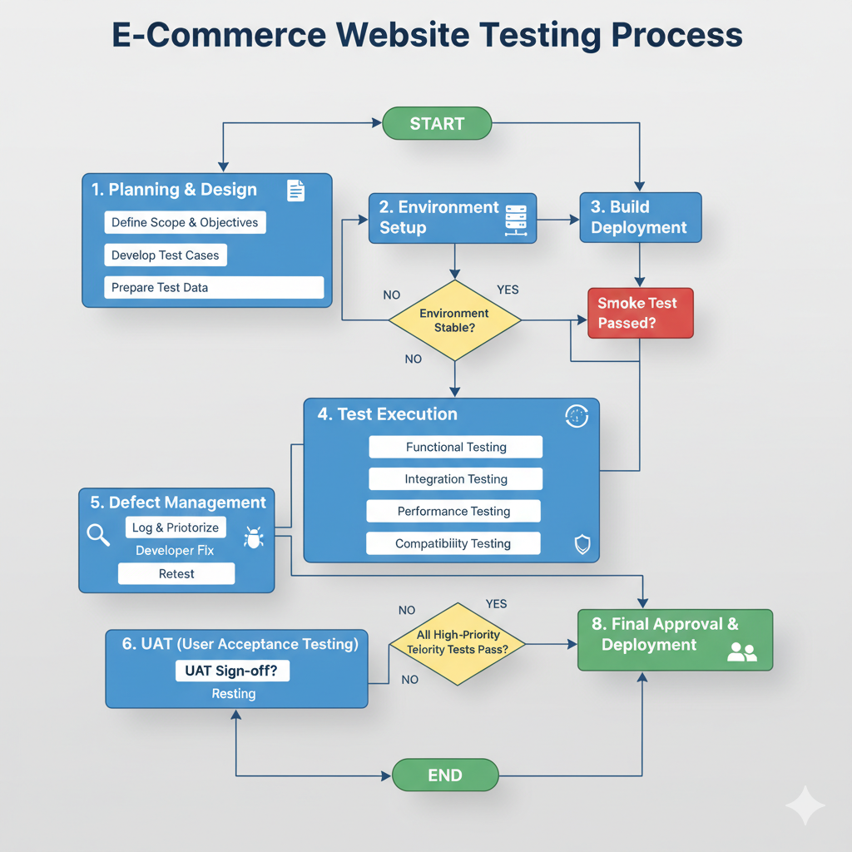
1. Planning & Design
- Define Scope & Objectives: Identify what needs to be tested and the goals of testing.
- Develop Test Cases: Create detailed scenarios that cover functionality, usability, and performance.
- Prepare Test Data: Generate or gather data required for testing (e.g., user accounts, products, transactions).

2. Environment Setup
- Prepare the testing environment, including servers, databases, and configurations.
- Decision Point: Is the environment stable?
  - No: Go back and stabilize the environment.
  - Yes: Proceed to build deployment.
3. Build Deployment
- Deploy the latest build/version of the e-commerce website to the testing environment.
- Smoke Test: Quick test to ensure the build is stable enough for detailed testing.
  - Failed: Fix issues before continuing.
  - Passed: Move to full Test Execution.
4. Test Execution
Perform various types of testing:
- Functional Testing: Verify that all website features (search, checkout, login, etc.) work as intended.
- Integration Testing: Check if different modules work together correctly (e.g., payment gateway integration).
- Performance Testing: Test website speed, load handling, and responsiveness.
- Compatibility Testing: Ensure the website works across different browsers, devices, and OS.
5. Defect Management
- Log & Prioritize: Record defects and assign priority.
- Developer Fix: Developers correct the issues.
- Retest: Verify that fixes work and don’t break other functionality.
This step often loops back into Test Execution until major defects are resolved.
6. UAT (User Acceptance Testing)
- Final testing by actual users or stakeholders.
- Decision Point: UAT Sign-off?
  - No: Address issues and retest.
  - Yes: Proceed to final approval.
7. High-Priority Test Check
- Before deployment, ensure all high-priority tests pass.
  - No: Go back to defect management or test execution.
  - Yes: Proceed to Final Approval & Deployment.
8. Final Approval & Deployment
- The build is approved for production.
- The website is officially deployed and ready for users.
Key Flow Notes
- The process is iterative: Failures in testing send the workflow back to previous steps (environment setup, defect management, etc.).
- Ensures quality, functionality, and performance before release.

